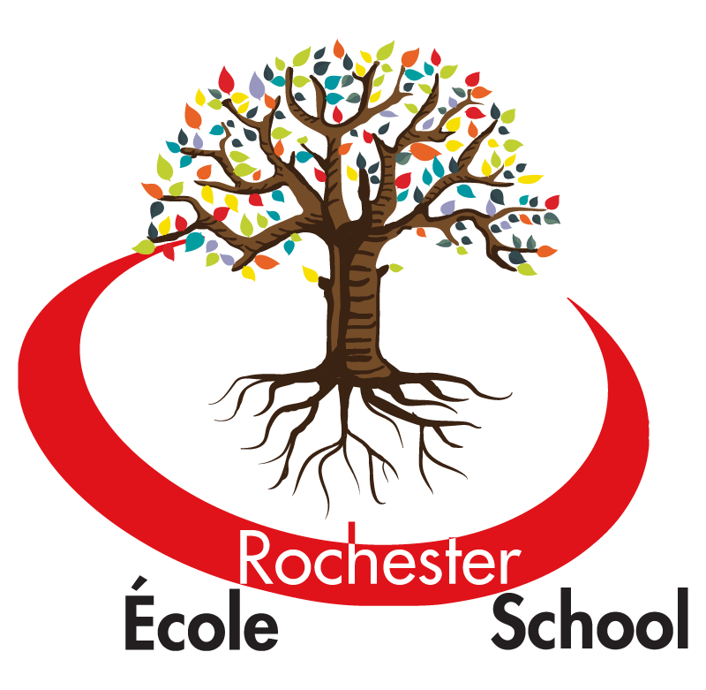
ÉCOLE ROCHESTER ELEMENTARY SCHOOL
411 Schoolhouse Street
Coquitlam B.C.
V3K 4Y7
(604) 939-4624
rochester@sd43.bc.ca

You are invited!
Rochester Community Barbeque

Thursday, June 1st, 2017
5:00 – 7:00 p.m.


Rochester Elementary in partnership with the Royal Bank of Canada would like to invite you to our Rochester Community Barbeque.

RBC is donating money and volunteer time to help Rochester make this event fun and memorable. Thanks to RBC employee and Rochester parent Susan Merritt, we are inviting you to come enjoy a hotdog, drink and more as you get to know and mingle with other Rochester families and friends. Place Maillardville will also be here putting on activities and games for all children to enjoy.

Please fill out the form below letting us know how many people will be attending and return it to your child’s classroom teacher as soon as possible. If you are able to volunteer some of your time either to help with set up from 4:00 – 5:00 or clean up from 7:00 – 8:00 please email Mme St-Arnaud at lstarnaud@sd43.bc.ca.
------------------------------------------------------------------------------------------------------

Yes, ____________ from our family will attend the Rochester Community Barbeque.
Number of people
